Sophomore and Junior
ENDODONTIC
Manual

Endodontic Preclinical
Didactic and Laboratory Courses
83:140 and 83:141

Summer

THE UNIVERSITY OF IOWA
COLLEGE OF
DENTISTRY

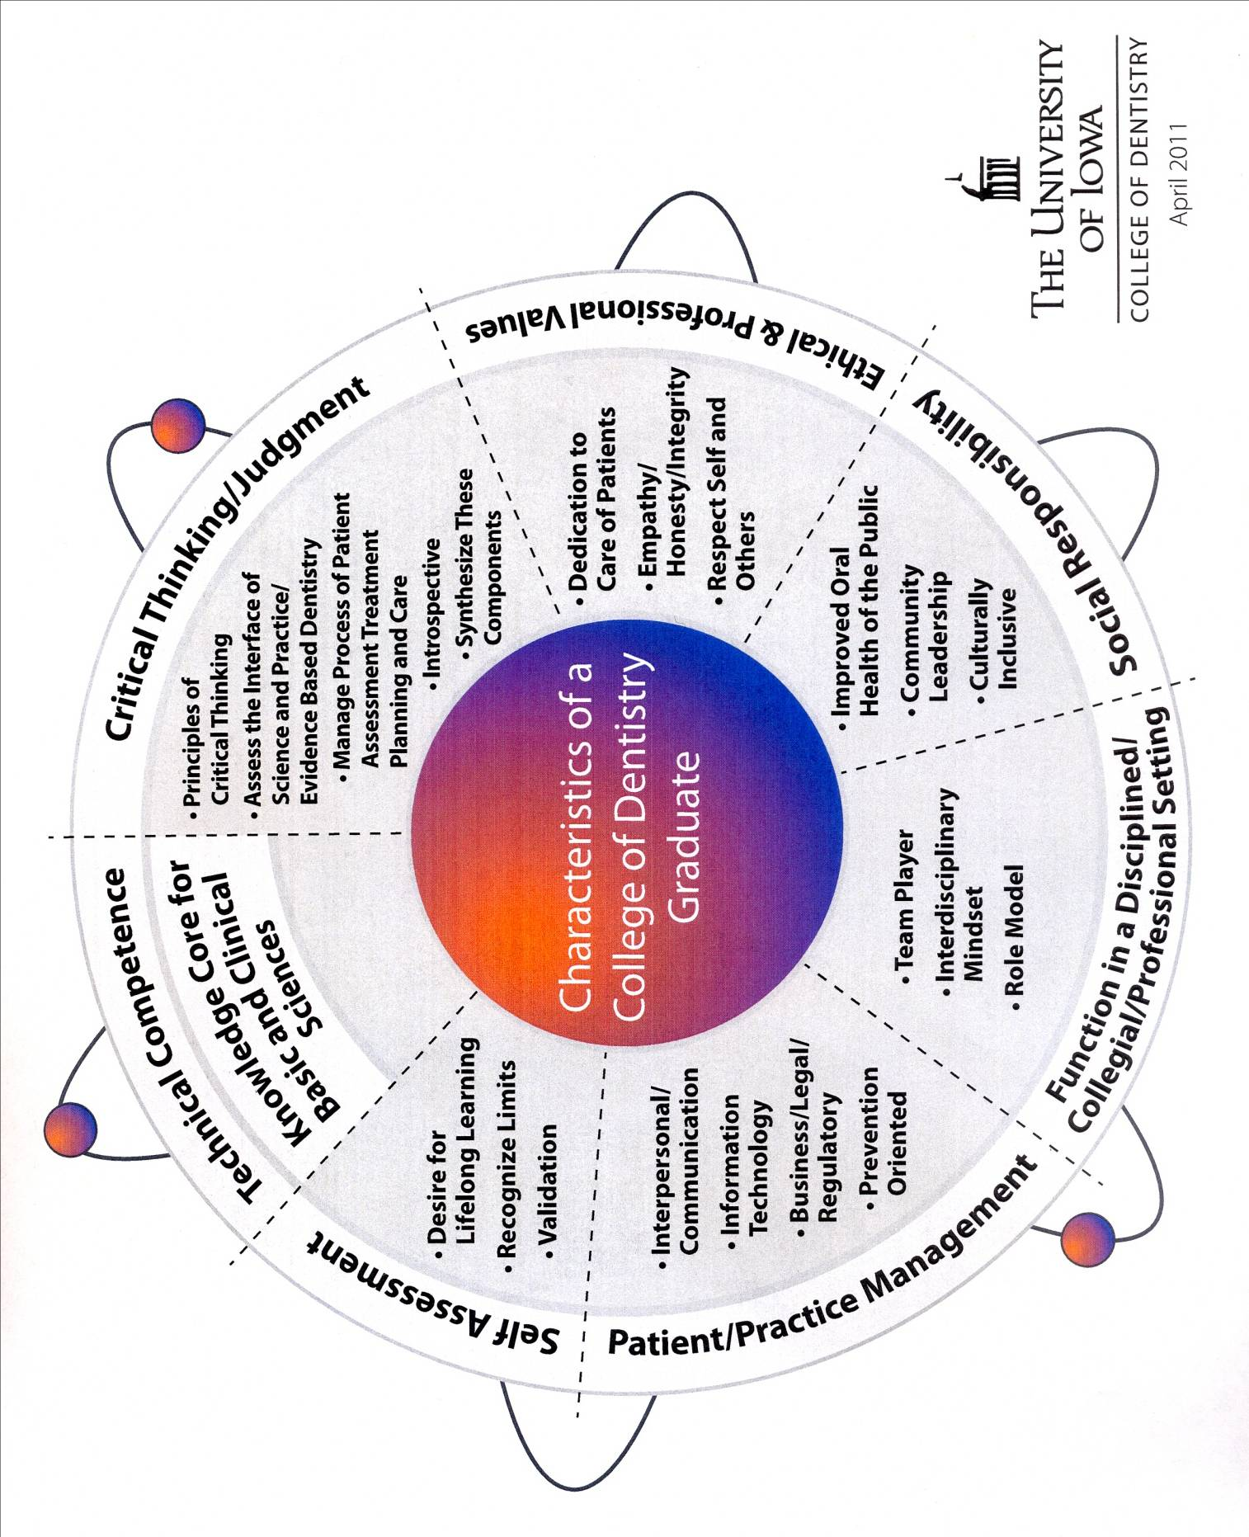

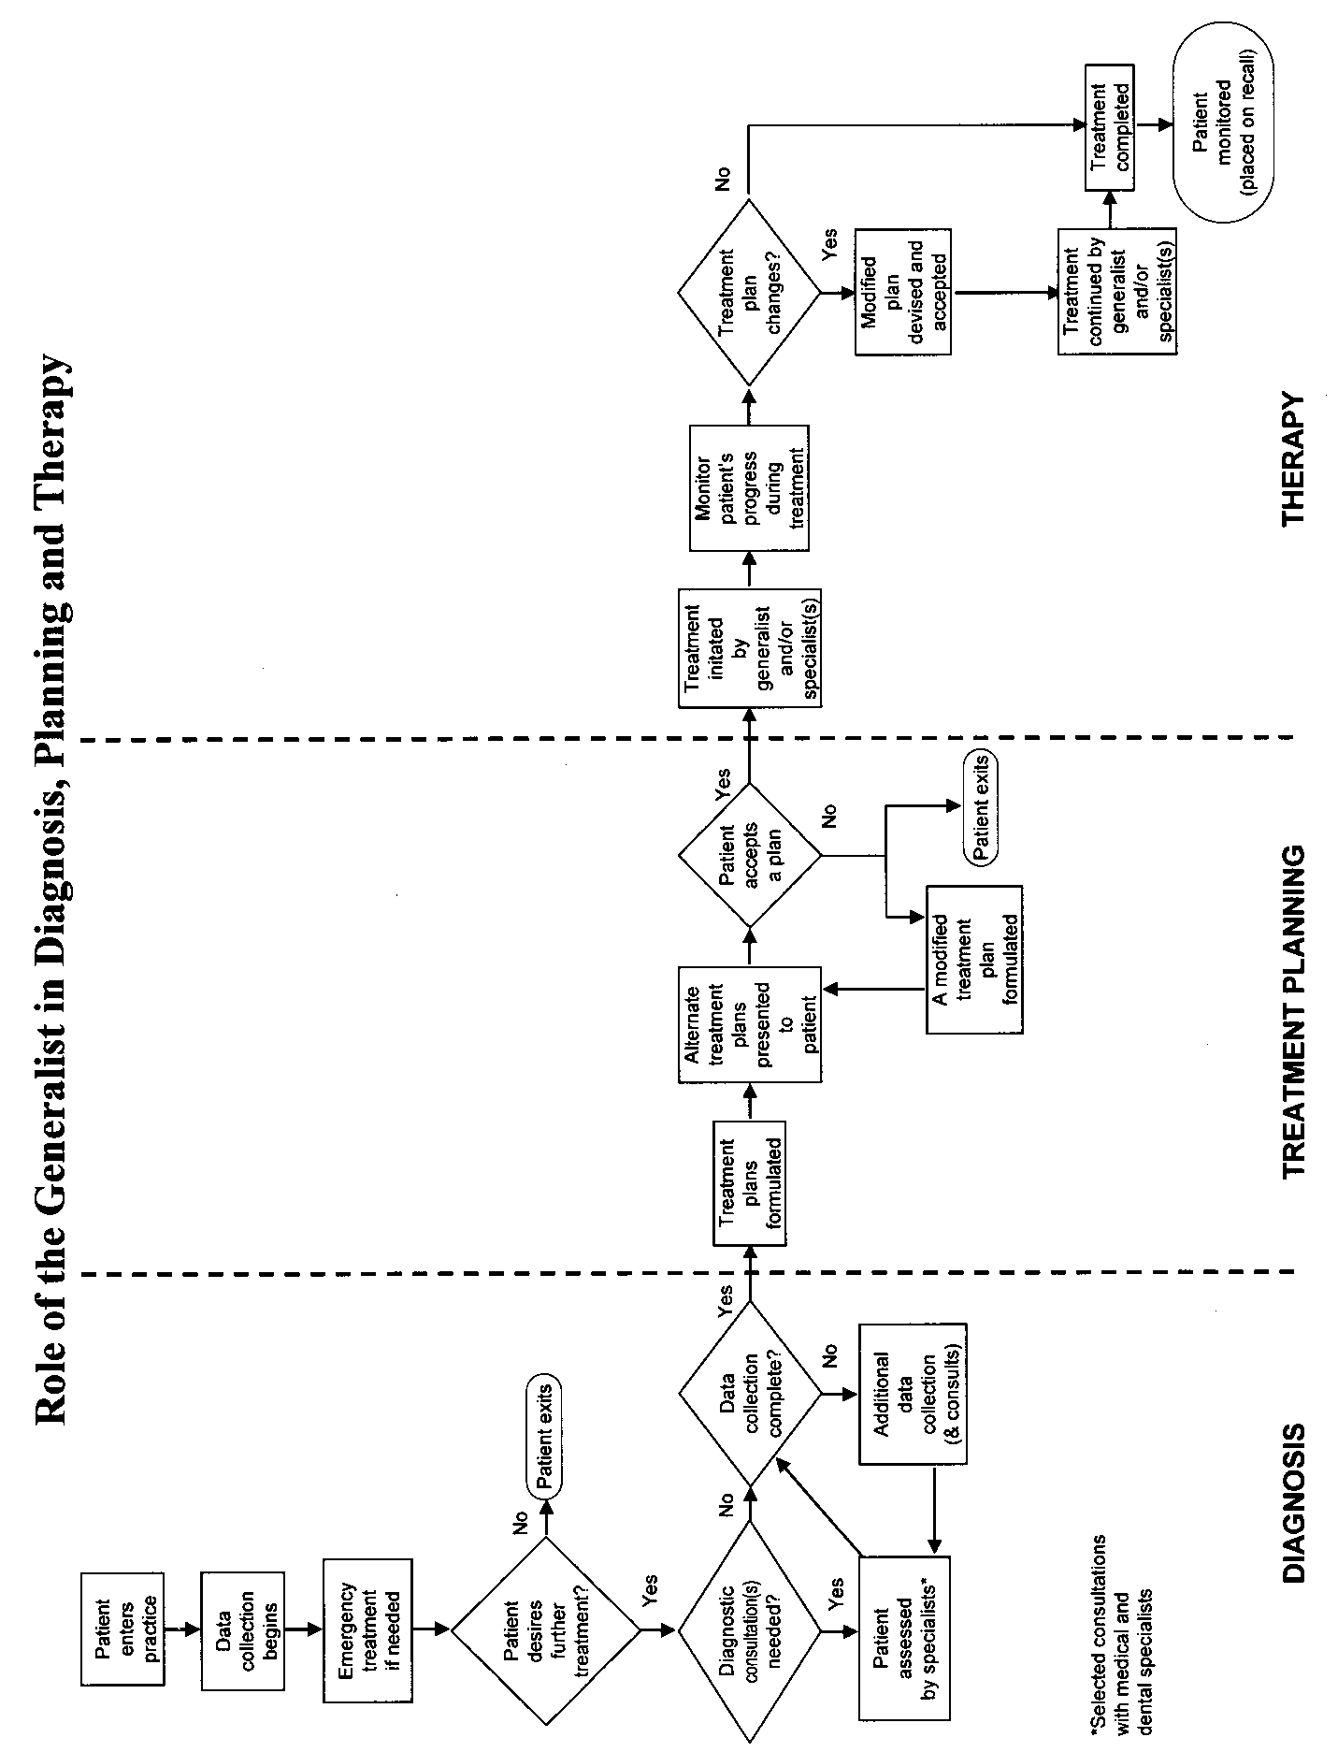
American Association of Endodontists Case Difficulty Assessment Form

PATIENT CONSIDERATIONS
CRITERIA AND SUBCRITERIA | MINIMAL DIFFICULTY | MODERATE DIFFICULTY | HIGH DIFFICULTY
MEDICAL HISTORY | No medical problem (ASA Class 1*) | No medical problem (ASA Class 2*) | Complex medical history/serious illness/disability (ASA Class 3-5*)
ANESTHESIA | No history of anesthesia problems | Vasoconstrictor intolerance | Difficulty achieving anesthesia
PATIENT DISPOSITION | Cooperative and compliant | Anxious but cooperative | Uncooperative
ABILITY TO OPEN MOUTH | No limitation | Slight limitation in opening | Significant limitation in opening
GAG REFLEX | None | Gags occasionally with radiographs/treatment | Extreme gag reflex which has  compromised past dental care
EMERGENCY CONDITION | Minimum pain or swelling | Moderate pain or swelling | Severe pain or swelling
DIAGNOSTIC AND TREATMENT CONSIDERATIONS
DIAGNOSIS | Signs and symptoms consistent with recognized pulpal and periapical conditions | Extensive differential diagnosis of usual signs and symptoms required | Confusing and complex signs and symptoms: difficult diagnosis  History of chronic oral/facial pain
RADIOGRAPHIC DIFFICULTIES | Minimal difficulty obtaining/interpreting radiographs | Moderate difficulty obtaining/interpreting radiographs (e.g., high floor of mouth, narrow, low palatal vault, presence of tori) | Extreme difficulty obtaining/interpreting radiographs (e.g., superimposed anatomic structures)
POSITION IN THE ARCH | Anterior/premolar  Slight inclination (<10°)  Slight rotation (<10°) | 1st molar  Moderate inclination (10-30°)  Moderate rotation (10-30°) | 2nd or 3rd molar  Extreme inclination (>30°)  Extreme rotation (>30°)
TOOTH ISOLATION | Routine rubber dam placement | Simple pretreatment modification  required for rubber dam isolation | Extensive pretreatment modification required for rubber dam isolation
MORPHOLOGIC  ABERRATIONS OF CROWN | Normal original crown morphology | Full coverage restoration  Porcelain restoration  Bridge abutment  Moderate deviation from normal tooth/root form (e.g., taurodontism, dens in dente)  Teeth with extensive coronal destruction | Restoration does not reflect original anatomy/alignment  Significant deviation from normal e.g., fusion, germination, dens in dente)
CANAL AND ROOT MORPHOLOGY | Slight or no curvature (<10°)  Closed apex <1 mm diameter | Moderate curvature (10-30°)  Crown axis differs moderately from root axis. Apical opening 1-1.5 mm in diameter | Extreme curvature (>30°) or S-shaped curve  Mandibular premolar or anterior with two roots/canals  Maxillary premolar with 3 roots  Canal divides in the middle or apical third  Very long tooth (>25 mm)  Open apex (>1.5 mm in diameter)
RADIOGRAPHIC APPEARANCE CANAL(S) | Canal(s) visible and not reduced in size | Canal(s) and chamber visible but reduced in size  Pulp stones | Indistinct canal path  Canal(s) not visible
RESORPTION | No resorption evident | Minimal apical resorption | Extensive apical resorption  Internal resorption  External resorption
ADDITIONAL CONSIDERATIONS
TRAUMA HISTORY | Uncomplicated crown fracture of mature or immature teeth | Complicated crown fracture of mature teeth  Subluxation | Complicated crown fracture of mature teeth  Horizontal root fracture  Alveolar fracture  Intrusive, extrusive or lateral luxation  Avulsion
ENDODONTIC TREATMENT HISTORY | No previous treatment | Previous access/treatment without complications | Previous access/treatment with complications (e.g., perforation, non-negotiated canal, ledge, separated instrument)  Previous surgical or nonsurgical endodontic treatment completed
PERIODONTAL-ENDODONTIC CONDITION | None or mild periodontal disease | Concurrent moderate periodontal disease | Concurrent severe periodontal disease  Cracked teeth with periodontal complications  Combined endodontic/periodontic lesion  Root amputation prior to endodontic treatment

American Society of Anesthesiologists (ASA) Classification System*
Class 1: No systemic illness. Patient healthy.
Class 2: Patient with mild degree of systemic illness, but without functional restrictions, e.g., well-controlled hypertension.
Class 3: Patient with severe degree of systemic illness which limits activities, but does not immobilize the patient.
Class 4: Patient with severe systemic illness that immobilizes and is sometimes life threatening.
Class 5: Patient will not survive more than 24 hours whether or not surgical intervention takes place.

University of Iowa College of Dentistry
Patient Consent for Endodontic Procedures
This form briefly explains endodontic (root canal) treatment including some of the risks and benefits. Please read the following lines and feel free to discuss any aspect of your treatment, then sign at the bottom where indicated
- I understand that root canal treatment is a procedure that will allow me to keep a tooth that might otherwise have to be removed. It usually involves making an opening in the tooth to remove damaged soft tissue that runs through the root. The space that this tissue occupied is then cleansed and a filling material is placed in this space.
- I understand that root canal treatment is usually successful. As with any branch of medicine or dentistry, no guarantee of success can be given. On occasion, a tooth that has received root canal treatment may require additional treatment or extraction. Additional fees would likely be incurred with additional procedures.
- I understand the number of visits and X-rays may vary with the difficulty of the case.
- I understand local anesthetics and a rubber dam are required for optimal results. In situations when the tissue in and around the tooth are extremely inflamed, obtaining profound anesthesia can be difficult.
- I understand the alternative to performing root canal treatment can be increasing pain, infection, bone and tissue destruction, and extraction. The removal of a tooth may require other types of dental procedures and expense.
- I understand that re-treating a previous root canal or treating a root canal started in other dental offices may have different outcomes than expected due to the difficulty involved.
- I understand there are possible complications in root canal treatment, including but not limited to:
Curved canals, curved roots
Calcification in root canal space
Crown or root fracture
Swelling or discoloration of the soft or hard tissues
Pain during or following treatment
Procedural difficulties such as instrument separation, root perforation, or overextension of the filling material
- I understand that periodic re-evaluation of the tooth is recommended following the completion of the root canal treatment.
- I understand that I am free to withdraw my consent and discontinue treatment at any time. I also understand that if the root canal treatment is not completed, retention of the tooth might be compromised. Pain, swelling, infection, and extraction may occur.
- I understand that emergency service is available by calling my endodontic treatment provider at __________________________________ or by calling 335-7469 (daytime weekdays), or 356-1616 (after hours).

I understand that after root canal treatment, the tooth will always need a new filling or crown. The fee for the root canal treatment does not include the fee for the filling, crown, or of any fees for periodontal (gum) treatment. I have also received information and an estimated fee for related procedures that might be necessary (crown lengthening, post, foundation, etc.) and for the final restoration. I also understand that after root canal treatment the new filling or crown must be placed as soon as possible.

I hereby consent to root canal treatment on tooth #________. The root canal fee is $_______
Patient Name: Signature:______________________ Date:___________
Student:______________________Faculty: ______________________ Date:___________

Section 2

University of Iowa Endodontic Curriculum
First Year
- Introduction to Endodontics
Endodontic Lecture - Canal and Root Morphology
Second Year
Fall
- Pathology of the Pulp and Periapex
- Diagnosis of Pulp and Periapical Pathosis I
- Diagnosis of Pulp and Periapical Pathosis II
- Diagnosis of Pulp and Periapical Pathosis III
Spring
- Endodontic Microbiology
- Tooth Development
- Pulpal Physiology
- Pulpal Histology
- Preclinical Endodontics
  - Didactic Course
  - Laboratory Course
Third Year
- Junior Clerkship
  - Didactic Course
  - Clinical Course
Fourth Year
- Family Dentistry
  - Didactic Course – Endodontic Seminars
  - Clinical Course

Section 3

INTRODUCTION AND COURSE GRADING
OF THE ENDODONTIC PRECLINICAL COURSE

The primary goal of this course is to teach students the biologic principles and technical aspects of nonsurgical root canal treatment. Root canal treatment will be completed on a number of extracted teeth. The student will review endodontic diagnosis and learn the basis of endodontic treatment planning.
Expected Outcomes: Following successful completion of the preclinical endodontic courses, students should be able to:
- Describe and apply principles of tooth development, pulp anatomy and structure, dentin, and periapical histology and physiology to clinical management of patients.
- Describe the anatomy and morphology of the teeth and associated pulp space.
- Describe the microorganisms involved with pulp and periradicular pathosis.
- Expose and interpret endodontic radiograph/images.
- Diagnose pulp and periapical pathosis.
- Determine appropriate treatment options, educate the patient, and obtain informed consent.
- Isolate the tooth with a rubber dam and access the pulp chamber.
- Negotiate canal spaces, perform passive step-back, and determine canal lengths.
- Perform straight line access and determine the master apical file.
- Clean and shape the root canal system with stainless steel files and nickel-titanium rotary instruments.
- Place calcium hydroxide as an intra-canal medicament.
- Fit master cones.
- Mix and place root canal sealer.
- Perform lateral compaction with gutta percha.
- Place appropriate temporary restorations.
- Describe the rationale for endodontic treatment and determine a prognosis based on the unique aspects of the case.
- Understand the criteria for evaluating treatment procedures and perform critical self evaluation.

SOPHOMORE ENDODONTICS

Course Director: Dr. William T. Johnson DDS, MS
Richard E. Walton Endodontic Professor and Head
Department of Endodontics S435
University of Iowa College of Dentistry
Iowa City, IA 52242-1001
319-335-7471 (Office Hours ...By Appointment)
william-t-johnson@uiowa.edu

Faculty: Dr. Richard Walton, Dr. Anne Williamson, Dr. Bruce Justman, Dr. Manuel Gomez, Dr. T.L. Green, Dr. David Drake,

Support Staff: Lisa Harless, Maria Polfliet, Julie Upchurch, and Tina Theisen

Lecture

A. Lectures are held in Galagan Auditorium 14A. Lecture times are posted.

B. Reading assignments will come from Endodontics: Principles and Practice (4th Edition, Drs. Mahmoud Torabinejad and Richard Walton, Editors) and the Sophomore Endodontics Manual. Textbook and Laboratory Manual Assignments are to be read prior to the dates of the lectures.

C. There may be discrepancies between material in the textbook reading assignments and the lecture. The laboratory manual and lecture material will prevail.

D. Attendance is required. The information given in lectures is directly applied in laboratory and next year in clinic; therefore it is knowledge required in the treatment of patients. Attendance sheets may be circulated during lectures for you to sign.

Examinations - Lectures

A. Five quizzes each worth 10 points will be given at the start of some lectures periods. The lowest score will be dropped in computing the grade. No make-up quizzes will be given. Quizzes will be based on accumulative material. The format for quizzes will be short answer, fill in the blank, and multiple-choice. Quizzes will comprise 40% of the lecture grade.

B. There will be one comprehensive, multiple-choice, short answer type of final exam. The final exam will comprise 60% of the lecture grade.
C. Quizzes and final examination will cover the lectures, reading material, and lab manual. If there is a discrepancy between the lecture, lab manual and/or text, the lecture material then the laboratory manual, then the textbook will prevail.

For all Quizzes and the Final Examination, the university code is required.

Laboratory

- Laboratory sessions generally follow the lectures and are scheduled from 2:15 until 4:45 PM in the Simulation Clinic.

- Grades are based on completed lab projects and two practical examinations. There are no provisions for make-up of the OSKE practical examination.

- All laboratory project grades are recorded on the grade sheet. Carefully preserve the grade sheet; this is the ONLY record of project evaluation. Do NOT take it out of the laboratory for any reason. A lost grade sheet will require repetition of the involved projects.

D. It is possible to complete all work during regular lab time if you:
          - Prepare for each session by doing the required reading prior to the session.
          - Come to lab on time and stay until closing (4:45).
Note: Student’s progress at different rates and the teeth provided provide varied degrees of difficulty. Times indicated are general guidelines for project completion and are not deadlines.

This is the only preclinical experience you will have in preparation for patient care; take advantage of the opportunity! Your next experience will be with patients in the clinic. Clinical experiences will build on the principles you learn now! The knowledge and technical skills you learn in the laboratory are imperative to success in the clinic; with patient care you will encounter problems with diagnosis, pain and infection, anesthesia, isolation, visibility, film placement, patient management and compliance. You must be confident in your technique. We expect you to come to clinic armed with the information you have already acquired (the sophomore material will not be repeated) and apply that knowledge to patients you are treating, knowing that there are variables involved in patient care.

In the years to come you will struggle with many difficult clinical problems, however, the real battle is here, now, in these weeks of preparation. Whether you succeed in the future, is being determined today.

Self Evaluation is the final step in establishing competency. Students will use the clinical criteria learned in the procedural step checks to evaluate their work prior to instructor evaluation.
COURSE GRADING PROCEDURES

A. Lecture
 | 1. Quizzes = 4 quizzes at 10 points each  (note that 1 of the 5 quizzes is dropped) | 40 percent
 | 2. Final Examination | 60 percent
 | TOTAL Lecture Points | 100 percent

B. Laboratory
 | 1. | Laboratory Projects | 40 percent
 | 2. | Practical Examination - Molar Access | 20 percent
 |  | Practical Examination - OSKE | 40 percent
 | TOTAL Laboratory Points |  | 100 percent

C. Grades are based on a percentage of points obtained divided by total points possible:
A = 90 - 100
B = 82 - 89
C = 75 - 81
D = 65 - 74
F = Below 65
The top and bottom of each category A to D may receive a + or –

Remediation for any students receiving a grade of F on the didactic or the laboratory portion of the course will be mandatory and must occur before the starting of the fall clerkship. The time, place, and requirements of remediation will be determined by the faculty.

Students having a grade of D may have inadequate knowledge and/or skill to treat patients in the Endodontic Clerkship (clinic). Additional Instruction may be required of students with a grade of D on the didactic or laboratory portion of the course in order to demonstrate clinical competence.
D. Accommodations for Students with Disabilities
Students seeking accommodations for disabilities should contact the Dean of Students and the Course Director.
E. Tutorial Program
The Department of Endodontics provides tutorial assistance for students in the Sophomore Endodontic Course. Although specifically intended for students that may be having difficulty in a particular area of study, any student is encouraged to seek assistance in areas of interest or concern. The Course Director may select students for participation to gain additional instruction.

Simulation Clinic Dress Code - As a professional health care provider you are expected to adhere to established policies and procedures while in the laboratory. Please follow the guidelines that have already been distributed for appropriate dress in the Simulation Clinic. Wearing open-toed shoes, shorts, or baseball caps is prohibited. Please wear the following at all times when in contact with actual or simulated teeth: protective eyewear, mask, gloves, and a clean simulation clinic smock.

Observance of the Collegiate Honor Code and ethical behavior are expected and required. Cheating will not be tolerated in any form!

Summer Lecture / LaboratorySchedule
Lec # | Date | Lecturer | Lecture | Lab # | Laboratory Activity
1 | May 3  Thursday 1:00-2:00PM | Drake  Galagan 14A | Endodontic Microbiology – |  | No laboratory period
2 | May 3  Thursday 2:00-3:00PM | Justman  Galagan 14A | An Overview of Root Canal Treatment |  | No laboratory period
3 | May 9  Wed AM | Johnson  Galagan 14A | Introduction and review of  Internal Anatomy  Endodontic Radiography | 1 | - Check into lab  - Instrument review  - Introduction to digital radiography
4 | May 9  Wed PM | Johnson  Galagan 14A | Access Preparation  Canal Negotiation | 2 | - Demonstration of anterior access  - Access preparation in unmounted anteriors (3)  - Canal negotiation in unmounted anteriors
5 | May 15  Tuesday | Johnson  Galagan 14A | Quiz 1  Passive Step-back  Working Length (WL)  Straight Line Access (SLA)  Master Apical File (MAF) | 3 | - Access preparation in mounted anteriors (3)  - Canal negotiation in mounted anteriors  - Passive step-back in mounted and unmounted anteriors
6 | May 17  Thursday | Johnson  Galagan 14A | Cleaning and Shaping | 4 | - WL in unmounted via direct observation  - WL in mounted incisors with digital radiography  - SLA/MAF of anterior teeth
7 | May 22  Tuesday | Justman  Galagan 14A | Quiz 2  Nickel-Titanium Rotary Instrumentation I | 5 | - SLA/MAF of anterior teeth  - SS Cleaning and Shaping and Apical Clearing of unmounted maxillary anterior and unmounted canine
8 | May 24  Thursday | Justman  Galagan 14A | Nickel-Titanium Rotary Instrumentation II | 6 | - SS Cleaning and Shaping and Apical Clearing of mounted maxillary anterior and mounted canine
9 | May 25  Friday | Walton  Galagan 14A | Diagnosis / Clinical Applications of Pulp and Periapical Pathosis | 7 | - SS/Nickel-titanium Cleaning and Shaping of umounted mandibular incisor (Hi-Bench Lab)
10 | May 29  Tuesday | Gomez  Galagan 14A | Quiz 3  Obturation | 8 | - Demonstration of premolar access  - Perform an access on the unmounted premolar  - SS/Nickel-titanium Cleaning and Shaping of mounted mandibular incisor, Premolar access, WL, SLA/MAF
11 | May 31  Thursday | Johnson  Galagan 14A | Intracanal Medicaments,  Temporary Restorations, Restoration of the Endodontically Treated Tooth | 9 | - Access unmounted premolar  - WL determination unmounted premolar  - SLA/MAF unmounted premolar, Cleaning and Shaping
12 | June 1  Friday | Williamson  Galagan 14A | Quiz 4  Endodontic Treatment Planning, Patient Education, and Isolation | 10 | - Demonstration of molar access  - Access unmounted molars  - Access mounted mandibular molar  - WL determination in molars
13 | June 5  Tuesday | Williamson  Galagan 14A | Procedural Accidents | 11 | - Demonstration of obturation / sealer mixing  - Obturate mounted anterior teeth  - Place temporary restoration in an anterior tooth
14 | June 7  Thursday | Gomez  Galagan 14A | Endodontic prognosis | 12 | - SLA/MAF in unmounted and maxillary molar  - SS Cleaning and Shaping of unmounted maxillary molar (Hi Bench Lab)  - Determine a WL with the Apex Locator
15 | June 12  Tuesday | Walton  Galagan 14A | Diagnosis: Pulp and Periradicular Pathosis | 13 | - SS/Nickel-titanium Cleaning and Shaping of unmounted premolar -SS/Nickel-titanium Cleaning and Shaping of mounted molar – RD Placement
16 | June 14  Thursday | Walton  Galagan 14A | Quiz 5  Pulp and Periradicular Diagnosis Exercise: Lab manual page 116 | 14 | - Obturation of mounted mandibular molar  - Temporization of molar with Cavit/IRM
17 | June 15  Friday |  | No Lecture – report directly to the Hi Bench Lab at 1:00 p.m. | 15 | - Practical Examination (OSKE Format - Bring a #2 pencil)  - Calcium hydroxide (CaOH) placement
18 | June 19  Tuesday |  | No Lecture – report directly to the simulation clinic at 1:00 p.m. | 16 | - Practical Examination - Access preparation on mounted maxillary molar  Continue with projects
19 | June 21  Thursday | Galagan 14A | FINAL EXAMINATION  Bring a #2 pencil | 17 | - Complete all projects
20 | June 22  Friday |  | LABORATORY CHECK-OUT | 18 | - Complete all projects  - Check-out

Reading Assignments – Lecture and laboratory
Sophomore Endodontic Reading Assignments are from Principles and Practice of Endodontics, Torabinejad and Walton, WB Saunders Co., 4th edition, 2008, unless otherwise indicated.
Lec | Date | Lecture | Lab | Laboratory
1 | May 3  Thursday 1-2:00 PM | Chap. 3 “Endodontic Microbiology” pp. 38-48. |  | No laboratory period
2 | May 3  Thursday 2-3:00 PM | Chapter 12 “Instruments” pp. 204-15. |  | No laboratory period
3 | May 9  Wed AM | Chap. 13 "Internal Anatomy” pp. 216-229.  Appendix A pp. 419-433.  Chap. 11 “Endodontic Radiography” pp. 185-203. | 1 | Manual Section 5 Lab Directions for Lab #1 p. 26  Manual "Introduction and Course Grading pp.8-9  Manual Section 4 Endodontic Instruments pp. 12-22  Manual Section 6 Endodontic Radiography p. 44-48
4 | May 9  Wed PM | Appendix A "Pulpal Anatomy/Access Preparation" pp. 419-433.  Chap 14 "Access Preparation and Length Determination" pp. 236-257. Chap 18 “Procedural Accidents” pp. 322-328 | 2 | Manual Section 5 .Lab Directions for Lab #2 p. 29  Manual Section 7 Coronal Access Preparation pp.49-61  Manual Section 8 Initial Canal Exploration / Passive step-back pp. 63-66
5 | May 15  Tuesday | Chap 14 "Access Preparation and Length Determination" pp. 236-257  Chap 15 “Cleaning and Shaping pp. 258-278. | 3 | Manual Section 5 Lab Directions for Lab #3 p.30  Manual Section 8 Initial Canal Exploration / Passive step-back pp 63-66  Manual Section 9 Working Length Determination pp.67-71  Manual Section 10 Straight Line Access / Master Apical File pp.72-75
6 | May 17  Thursday | Chap 15 “Cleaning and Shaping pp. 258-278.  Chap 18 “Procedural Accidents” pp. 328-334 | 4 | Manual Section 5. Lab Directions for Lab #4 p. 31
7 | May 22  Tuesday | Chap 15 “Cleaning and Shaping 258-278. | 5 | Manual Section 5 Lab instructions for Lab #5 p. 32  Manual Section 11 Cleaning and Shaping pp. 76-93
8 | May 24  Thursday | Chap 15 “Cleaning and Shaping 258-278. | 6 | Manual Section 5 Lab instructions for Lab #6 p. 33  Manual Section 11 Cleaning and Shaping pp. 76-93
9 | May 25  Friday | Chap 1 “The Dental Pulp and Periradicular  Tissues” pp. 1-20. Chap 4 “Pulp an Periradicular Pathosis” pp.49-67  Chap 5 "Diagnosis and Treatment Planning” 68-93 | 7 | Manual Section 5 Lab instructions for Lab #7 p. 34  Manual Section 11 Cleaning and Shaping pp. 76-93
10 | May 29  Tuesday | Chap. 17 “Obturation” pp. 298-321.  Chap 18 “Procedural Accidents” pp. 334-336 | 8 | Manual Section 5 Lab instructions for Lab #8 p. 36  Manual Section 11 Cleaning and Shaping pp. 76-93
11 | May 31  Thursday | Chap 15 “Temporazation” pp. 279-286  Chap 16 "Preparation for Restoration and Temporization" pp 287-297 Chap 18 “Procedural Accidents” pp. 336-339 | 9 | Manual Section 5 Lab instructions for Lab #9 p. 34  Manual Section 7 Coronal Access Preparation pp. 49-61  Textbook Appendix Pulpal Anatomy / Access Preparation pp561-574.
12 | June 5  Tuesday | Chap 5 "When and How To Refer" and "Patient Education” pp. 84-93.  Chap 14 "Isolation" pp. 230-236. | 10 | Manual Section 5 Lab instructions for Lab #10 p. 37  Manual Section 7 Coronal Access Preparation pp. 49-61  Textbook appendix Pulpal Anatomy/Access Preparation , pp 561-574
13 | June 7  Thursday | Chap 18 “Procedural Accidents” pp. 322-339 | 11 | Manuel Section 5 Lab Directions for Lab #11 p. 38  Manual Section 12 Intracanal Medications/Coronal Temporizations pp. 94-96  Manual Section 13. Obturation pp. 97-107
14 | June 8  Friday | Chap 21 ”Evaluation of Success and Failure” pp. 376-390. | 12 | Section 5 Lab Directions for Lab #12 p. 39  Manual Section 11 Cleaning and Shaping 91-93
15 | June 12  Tuesday | Chap 5 “Diagnosis and Treatment planning” pp. 68-84 | 13 | Section 5 Lab Directions for Lab #13 p. 40  Review as necessary
16 | June 14  Thursday | Chap 5 “Diagnosis and Treatment planning” pp. 68-84  Laboratory Manual – Diagnosis Exercise pp. 116-118 | 14 | Section 5 Lab Directions for Lab #15 p. 42  Manual Section 12 Intracanal Medications/Coronal temporizations  Manual Section 13. Obturation pp. 95-105
17 | June 15  Friday | No lecture - report to the Hi Bench Lab at 1:00 p.m. | 15 | Practical examination - OSKE Format  Section 5 Lab Directions for Lab #14 p. 41
18 | June 19  Tuesday | No lecture – report to the simulation clinic at 1:00 p.m. | 16 | Practical examination - Access preparation of a mounted maxillary molar  Section 5 Lab Directions for Lab #16 p. 43
19 | June 21  Thursday | Final Examination | 17 | Section 5 Lab Directions for Lab #17 p. 43
20 | June 22  Friday | LABORATORY CHECK- OUT | 18 | Section 5 Lab Directions for Lab #18 p. 43  Check-Out

